
Raspberry
Cheesecake Cups
ITEM #GP2185
KEEP
FROZEN
LOT CODE:26827
BEST BEFORE:2027/02/28

Ingredients:Enrichedwheatflour(contains,whaetflour,Niacin,reduced Iron,Thiamine,mononitrate,Riboflavin,Folic Acid)Graham flour,sugar, palm oil, HighFructose corn Syrup,Molasses, salt,Baking Soda. Cream cheese(Milk ingredients,salt,Bacterial culture,xanthan gum,carob bean gum,guar gum,potassium sorbate). Cream , Raspberries, Modified corn starch, Citric acid, Concentrated carrot juice, Natural flavour, Salt, Potassium sorbate, Sodium benzoate.. dehydrated corn syrup, sugar, animal gelatin (bovine), skimmed milk powder, starch, flavouring. Stablizer(Sugar, glucose,water,Tetrasodium Pyrophosphate,Disodium Phosphate).

v
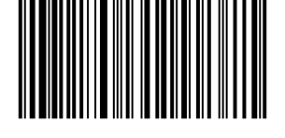
(01)10627146285572(15)250923(10)72722

Gastronomique pastry INC
7621 vantage way, Delta, BC V4G 1A6

